Title: skiba: a forester’s package to perform point extractions from Google Earth Engine
Authors: Tara Skiba, Tyler Gifford
Citable Nuggets
- Remotely sensed data can be easier to incorporate into forest studies and inventories if technological barriers are removed
- Existing python packages can be combined to develop a more efficient workflow to extract pixel values from remotely sensed data in GEE.
- Due to concerns about running sensitive coordinates through GEE, two buffering approaches were developed to use in conjunction with the point extraction tools.
Abstract

Introduction
Forests, which cover 31% of the Earth’s land area, are complex ecosystems with high variability and therefore challenging to study. A forest’s characteristics, such as composition and structure, are influenced not only by the previous forest ecosystems that preceded the current forest, but also environmental conditions, like temperature, rainfall, or sunlight intervals. While environmental factors are important to understanding forest systems, they are hard to generate and not consistently included in operational forest inventories. For example, rainfall would need to be collected daily to calculate average annual rainfall. Not only would this be difficult to obtain for small forest studies, but it also becomes impossible to quantify at large spatial scales, like national forest inventories (NFIs). Without this information provided, understanding about how environmental variables influence forest systems is limited. These information gaps have been filled using remotely sensed (RS) data as it has the three following characteristics: it is spatially uninterrupted, continuously monitored, and provides metrics that are best captured via RS methods. These valuable characteristics can be exploited to complement plot-based forest inventories to enable estimation of forest health, canopy structure, biomass, disturbance, and climate drivers at scales impossible through ground-based inventories alone.
Despite the plethora of existing RS data available, the specialized technical knowledge needed to access and handle geospatial data gas posed to be a significant barrier for foresters to overcome, preventing RS data from being used to its fullest potential. Existing geospatial software and programs are powerful but still require geospatial literacy and programming skills. Open-source programs like Python and R provide the most user flexibility with geospatial data handling but are technically advanced due to the programming required. Geospatial software like ArcGIS eliminates the majority of the programming knowledge needed through its program interface, but users must still have geospatial data knowledge to perform any operations. In addition, licenses may have to be purchased, which can be expensive. Even if users have the required technical knowledge and software available, other challenges remain. RS and raster datasets are collected and maintained by numerous government agencies, either domestically or internationally. These datasets can be downloaded from the agency’s website, which can pose issues not only with locating the desired dataset, but also with downloading these datasets which can be incredibly large. These challenges can make geospatial data retrieval, handling, and processing inefficient and slow.
A solution to the issue of data decentralization can be found when using Google Earth Engine (GEE)CITE, a free, public repository of many popular remotely sensed and geospatial datasets. These datasets are stored in a cloud server, which allow users to avoid having to download the large datasets locally, increasing efficiency. GEE also has a Code Editor where users can work completely on a cloud server and employs the JavaScript language. GEE has been integrated into existing geospatial analysis software. The GEE Toolbox (citation) allows for integration in ArcGIS products. The R package rgee (Aybar et al. 2020) provides GEE integration into the R environment by translating R code to Python and passing it to the Google Earth Enginge API. Meanhile, earthengine-api (ee) and geemap in Python do this that and that other. Such tools provide easier access to GEE and reduce some of the legwork needed to perform geospatial analysis. While GEE and related programs can help resolve the issues of accessing GEE datasets, the technical threshold for manipulating geospatial data is still high.
One way for RS data to be paired with operational forest inventories is to perform simple point extractions of the pixel value that contains an inventory plot’s coordinates. To accomplish this, users would have to upload their coordinates, access GEE and select a dataset, perform any necessary data manipulations to ensure object (file, format) compatibility, extract the desired information, and return the results. While these point extractions are possible to produce with existing software, there is a need to make this process more efficient and less technically complicated. This entire workflow can be distilled down to only require the user to provide the necessary input information and perform all other steps behind the scenes. The creation of a streamlined workflow would not only be beneficial to foresters lacking the technical knowledge to access RS data, but it would also allow experienced geospatial data users to perform simple point extractions quickly and efficiently.
Currently, a streamlined workflow that allows forest practitioners to specifically perform point-extractions from GEE-derived raster data for inventory coordinates without advanced coding or proprietary software does not exist. In this study, the skiba Python package was developed to combine existing GEE python packages into a system that minimizes the coding requirements and lowers the technical threshold previously needed. The goal of this project is to alleviate setup time to perform point extractions and reduce the number of steps required to access and retrieve data from Google Earth Engine in order for RS data to more efficiently be integrated into forest studies and inventories. As some inventories’ exact plot coordinates are protected due to confidentiality agreements in place, some users may have concerns with using these raw data in Google Earth Engine. In response, two approaches to buffer coordinate sensitive coordinate points were developed to prepare the data to be run through Google Earth Engine without requiring any coding skills. The combinations of point extraction and point buffering workflows developed reduce the time and required skills for foresters to incorporate RS data into forest studies and inventories.

Methods
Software design
The skiba Python package was designed as a point-and-click widget that removes much of the technical work needed to extract data from GEE-derived datasets. The package is divided into two collections: point extraction modules and coordinate buffering modules, which can be visualized in Figure []. ipywidgets provides the foundation for all modules to construct the visible(?) user interface. Functions from pandas and geopandas are leveraged in all modules to handle geospatial file handling. shapely, shapely.geometry, pyproj, and numpy are utilized to generate random coordinate points in the buffering approaches. geemap is exclusively called within point extraction modules to retrieve the pixel values for the provided coordinate points.

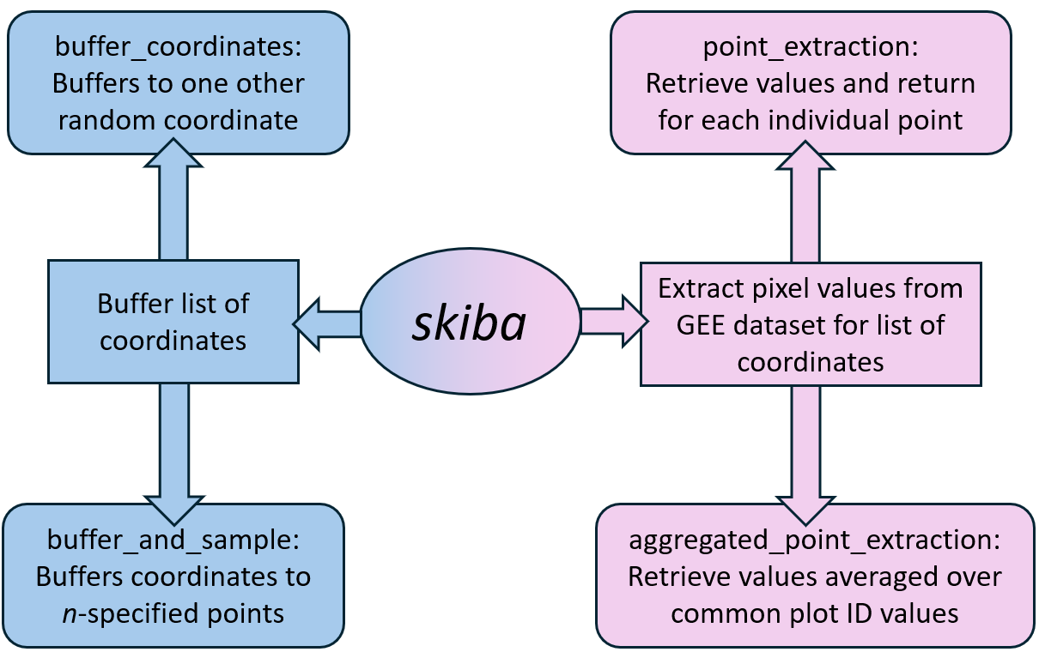

Point Extraction Modules
The point extraction modules require that GEE be initialized and authenticated prior to pixel extraction. When the modules’ interfaces are loaded(?), a widget box is shown for users to upload a CSV file of coordinate points is uploaded, select the GEE dataset of interest, and set filter dates. Acceptable GEE datasets must Images and ImageCollections, not FeatureCollections. Some limitations have been observed. For example, WorldClim Climatology V1 (WORLDCLIM/V1/MONTHLY) has a “month” image property that organizes the data that incompatible with the designed filtering process. Start and end dates to filter that datasets are required only for ImageCollections, and the user may refer to the dataset’s GEE documentation page to find dataset availability. The date filters may be left blank for Images.
Two point-extraction modules were created: point_extraction (PE) and aggregated_point_extraction (APE). Both modules perform the same extraction process but differ in aggregation technique. PE returns the extracted data for each coordinate uploaded, whereas APE extracts the pixel values then averages over shared plot IDs. The difference between returned results is demonstrated in Figure [].
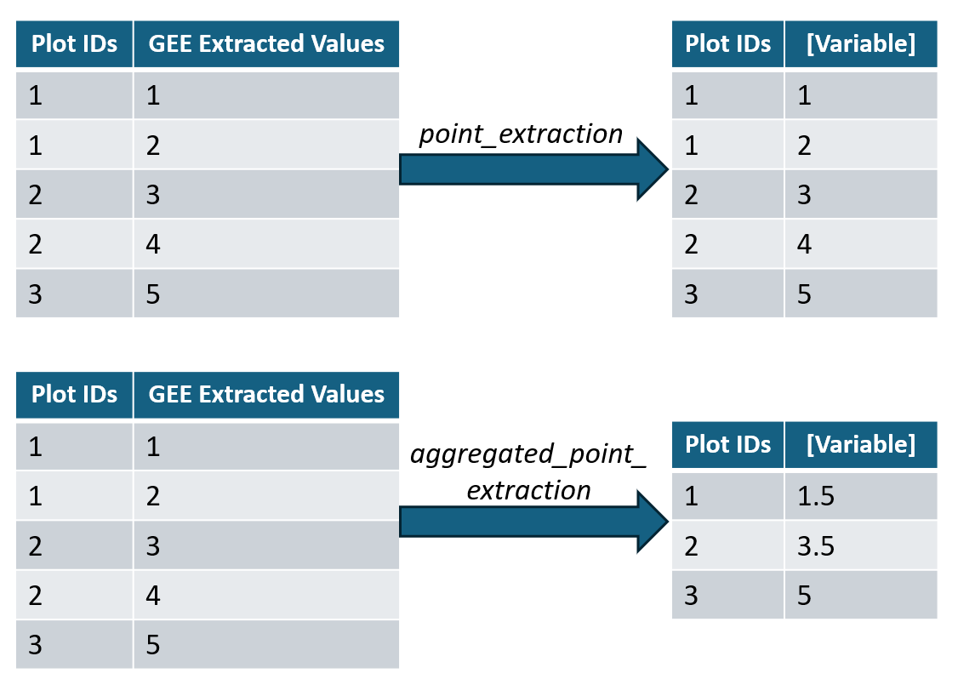
Coordinate Buffering Modules
Users who have concerns about using sensitive plot coordinates through GEE have the option to buffer coordinates prior to performing point extractions. In the coordinate buffering modules, users upload a CSV file containing the raw coordinates and set the buffer radius that randomized points will be generated within. This buffer radius is determined via the data’s user guide and the pixel size for the GEE dataset of interest. Plot coordinates are often designated as the plot center, and the plot radius can be large enough that it must be considered as well when determining an appropriate buffer radius. Users will have to consider some of these cases when the randomized coordinates are located in a pixel different than the original coordinates.
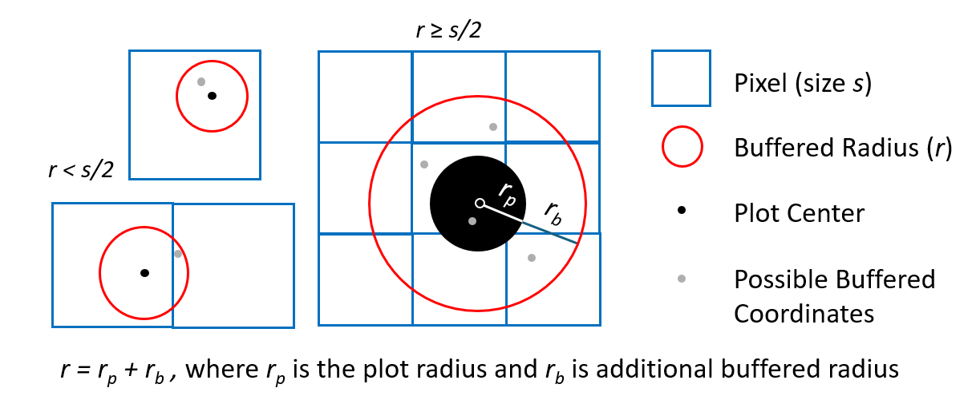
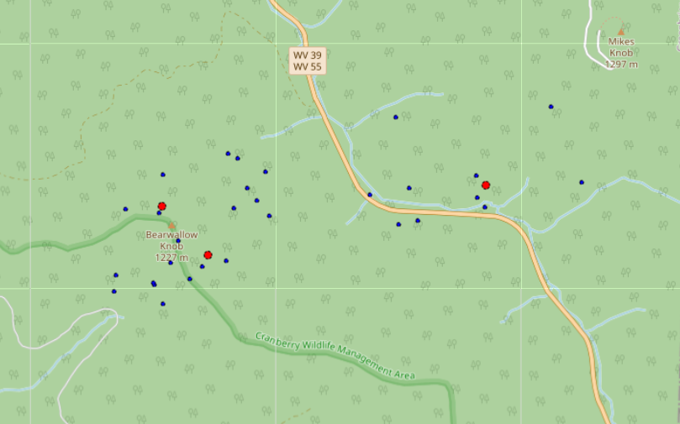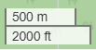Example of buffer_and_sample approach with r = 3000 ft and n = 10. Uploaded coordinates are marked red, and the 10 buffered coordinates are blue.

As these modules do not initialize GEE, the original plot coordinates are protected.
Input Data
CSV Columns | Accepted Names
latitude | lat, latitude, y, LAT, Latitude, Y
longitude | log, long, longitude, x, LON, Longitude, Long, X
plot ID | id, ID, plot_ID, plot_id, plotID, plotId

Usage
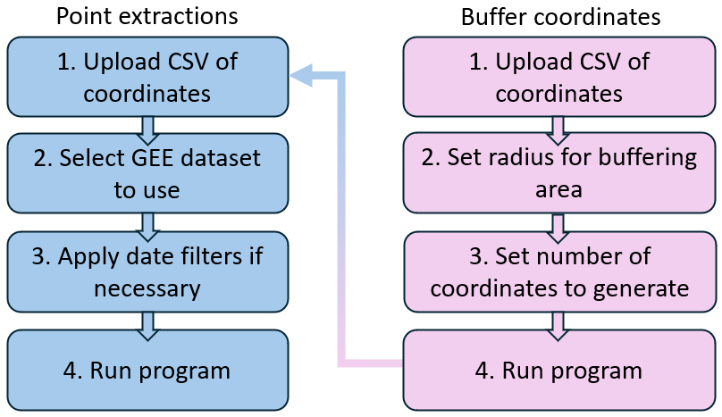
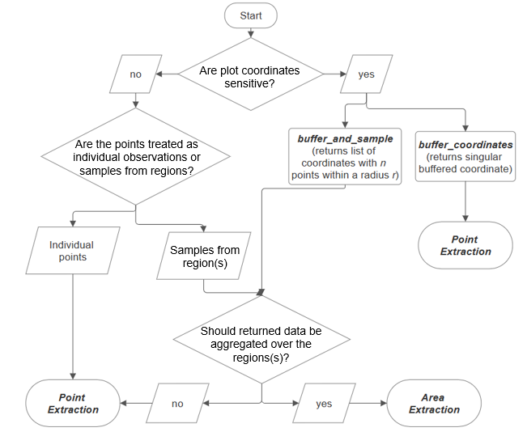
Random thoughts saved for later:
Remotely sensed data can also provide information that is collected via airborne or spaceborne vehicles like the Normalized Difference Vegetation Index (NDVI)
In addition to the daily measurement challenges, some metrics used to study forest systems like the Normalized Difference Vegetation Index (NDVI) are produced using expensive instruments that are commonly collected via airborne or spaceborne vehicles

As a python package, there is still coding knowledge needed to set up and install the required packages. To completely remove this technical barrier, a Streamlit web app was built for users to utilize this package without any prior local setup. This website authenticates GEE through a designated Google account to remove the need for the user to create their own.

Use active voice
For coherence, have the last part of a sentence be the same as the beginning of the next sentence.

